Premillennial Dispensationalism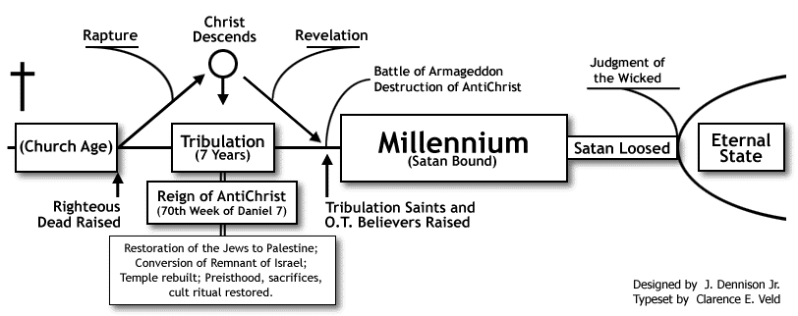

Historic Premillennialism
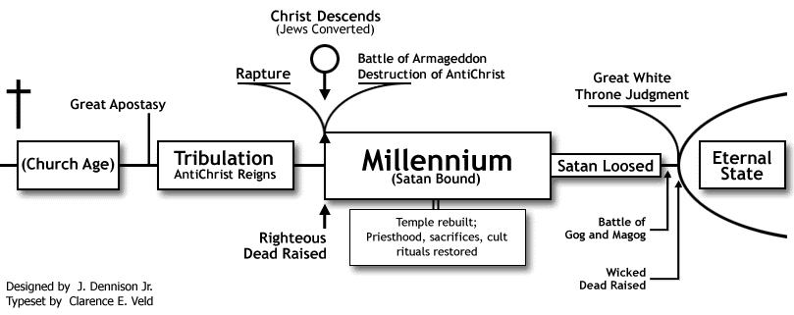

Postmillennialism
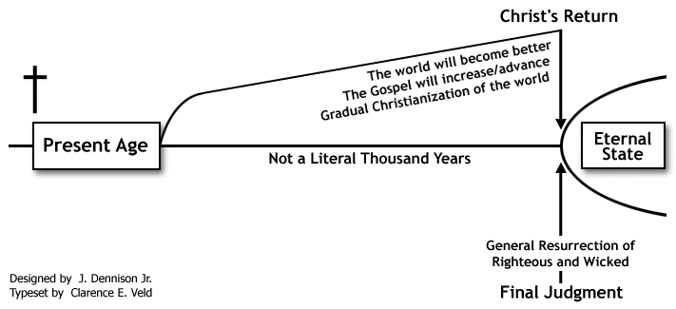
Questions to Consider
Where did millennial views come from?
Why do the millennial views seem to always include salvation for the Jews (apart from Christ in dispensationalism)?
In Historic and Dispensational Premillennialism, why is it important that the temple be restored and sacrifices continue?
How has this affected American Evangelicalism, and why is American Evangelicalism so driven by these millennial views?
Is there something behind it?

